**Design Document**



Politecnico di Milano

• Antonino Caminiti (mat. 835724)

• Daniele Gonella (mat. 827091)

• Matteo Scerbo (mat. 899823)

# 

**1. Introduction** **3**

A. Purpose 3

B. Scope 3

C. Definitions Acronyms, Abbreviations 3

D. Revision History 3

E. Reference Documents 3

F. Document Structure 3

**2. Architectural Design** **3**

A. Overview 3

B. Component View 3

C. Deployment view 3

D. Runtime View 3

E. Component Interfaces 3

F. Selected architectural styles and patterns 3

G. Other Design Decisions 4

**3. Algorithm design** **4**

**4. User Interface design** **4**

**5. Requirement Traceability** **4**

**6. Implementation, integration and test plan** **4**

**7. Effort Spent** **4**

**8. References** **4**

# 

# 1. Introduction

## A. Purpose

This document represents the D.D. (Design Document). Our goal is to give a detailed and complete description of the system in terms of its structural components and its architecture.

This document is directed to the developers who are going to implement the architectures, and the testers.

## B. Scope

### **1.2.1. Description of the given Problem**

We are going to design and implement a web application named “Travelendar+”.

The System will allow the users to

* Find the shortest available itinerary given the location of departure and destination, with possibility of modification in case of unforeseen circumstances
* Further customize said itinerary by stating their preferences of transport and desired pauses or breaks, customizing them by specifying how much the break should last and the given timeslot
* Buy and/or book tickets for public transports

The users will have to register (by inserting a username and a password) to be able to use the system. Every user has a set of travel preferences, which can be customized in general as well as for each itinerary, if necessary.

The main purpose will be to offer a quick, efficient, and reliable application to schedule the quickest routes complying to all the user’s events within the limits of feasibility.

### **1.2.2. Actual System**

The users will be logging in with their username (or, alternatively, their e-mail address or phone number) and password. The set of preferences will be the basis for all travels, and the users will only need to give as inputs the locations of departure and the destination, the time at which they should arrive to the destination, and the type of event.

After that, they will also be able to customize the preferences for the specific trip (such as some means of transport to avoid) and they will receive the shortest itinerary given these inputs.

The user will also have the further option to arrange the trip by buying/booking tickets for public transport if needed, once the itinerary has been set.

## C. Definitions Acronyms, Abbreviations

### **1.3.1. Definitions**

* Event: Locations the user has to go to within a certain deadline for a given timeframe
* Trip: The description of route, including the transports, the user takes on to get from the starting location to the event
* Step: A single part of a trip, corresponds to one mean of transport
* Break: An optional pause to consider from all trips and events, it has to be within a chosen timeframe and last for at least a chosen amount of time

### **1.3.2. Acronyms**

DB: Database

DBMS: Database Management System

RASD: Requirement Analysis and Specification Document

DD: Design Document

### **1.3.3. Abbreviations**

[Gn] - nth goal

[Dn] - nth goal

[Rn] - nth functional requirements

## D. Revision History

* DD 0.0.1 – Table of Content + 1. Introduction + 4. User Interface Design

## E. Reference Documents

## F. Document Structure

**Introduction:** this section introduces the design document. It contains a justification of his utility and indications on which parts are covered in this document that are not covered by RASD.

* **Architecture Design:** this section is divided into different parts:

1. Overview : this sections explains the division in tiers of our application
2. Component view : this sections gives a more detailed view of the components of the applications
3. Deployment view: this section shows the components that must be deployed to have the application running correctly.
4. Runtime view: sequence diagrams are represented in this section to show the course of the different tasks of our application
5. Component interfaces: the interfaces between the components are presented in this section
6. Selected architectural styles and patterns: this section explain the architectural choices taken during the creation of the application
7. Other design decisions

* **Algorithms Design:** this section describes the most critical parts via some algorithms. Pseudo code is used in order to hide unnecessary implementation details in order to focus on the most important parts.
* **User Interface Design:** this section presents mockups.
* **Requirements Traceability:** this section aims to explain how the decisions taken in the RASD are linked to design elements.
* **Implementation, integration and test plan:**  in this section we identify the order in which developers plan to implement the subcomponents of the system and the order in which we plan to integrate such subcomponents and test the integration.

# 2. Architectural Design

## A. Overview

High-level components and their interaction

## B. Component view

The following diagrams show the main components of the system and the interfaces through which they interact.

* The client side consists of only the web application on the customer's device.
* The server side has several subcomponents, as shown in the second picture.
  + These subcomponents manage different services offered to the customer, each interacting with different third parties.

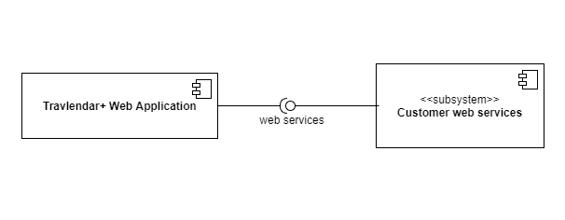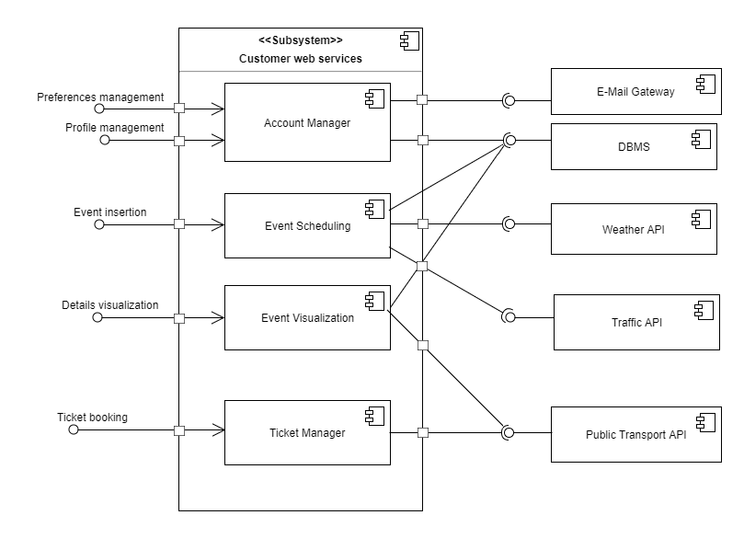

## C. Deployment view

## D. Runtime View

You can use sequence diagrams to describe the way components interact to accomplish specific tasks typically related to your use cases

## E. Component Interfaces

## F. Selected architectural styles and patterns

Please explain which styles/patterns you used why, and how

## G. Other Design Decisions

# 3. Algorithm design

Focus on the definition of the most relevant algorithmic part

# 4. User Interface design

Refer to the mockup provided in the R.A.S.D. – Section 3.1.1

# 5. Requirement Traceability

Explain how the requirements you have defined in the R.A.S.D. map to the design that you have defined in this document

# 6. Implementation, integration and test plan

Identify here the order in which your plan to implement the subcomponent of your system and the order in which you plan to integrate such sub-components and test the integration

# 7. Effort Spent

8/11/2017: Antonino Caminiti - 1 hour (table of content)

# 8. References